Benefits of Attending Church Regularly
by Michael Beresford
(Adapted from TGC Article by Steve Batman in 2023)
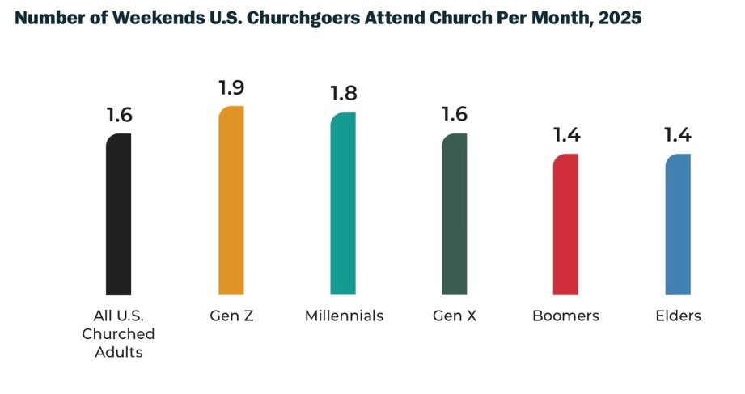
A recent Barna poll showed how many weekends a month Christians attend church in a month. The encouraging note is that younger adults are attending twice as much as 5 years ago. However, for the rest of the church, attendance frequency is falling off.
The concern is that priorities are shifting away from God, from the mission of the church and the devaluing of the being a part of the body of Christ.
It’s also very hard to gain momentum when you are talking with less then 50% of the congregation at any one time.
The other reason that this is troubling is that people are missing out on the benefits of going to church.

Here are 9 reasons that have been identified, undoubted there are more.
- Church attendance pleases and glorifies God. (Hebrews 10:24-25)
- Church attendance is an act of love to your neighbor. At church we engage in a means of God’s grace to us as we share it with others in the simple acts of greeting them, offering friendship and conversation, etc. It also sets a tone for those who see you go to church on a regular basis. Martin Luther said, “God doesn’t need you to go to church, but your neighbors do.”
- Church attendance can make you smarter. God reveals himself to us at church through the singing and preaching. (2 Timothy 2:7)
- Church attendance can make you healthier. Studies show that engaging in regular meaningful fellowship can reduce both stress and the risk of mortality by 55% on middles-aged adults.
- Church attendance can make you happier. Going to church increases hope which helps us and brings joy. (Romans 12:12) A Harvard study found weekly church attendance effectively improved the physical and mental health of millions of Americans and reduced mortality by 20-30% over a 15-year period. Other studies have asserted that faithful church attendance helps prevent despair that leads to deaths through decreased depression, suicide and substance abuse.
- Church attendance can make you more generous. The Bible teaches, and it’s reinforced at church that we are to ‘do good, to be rich in good works, to be generous and ready to share’ (1 Timothy 6:18). Generous people are more content.
- Church attendance can protect your marriage. There are countless influences pulling spouses apart, but faithful church attendance “together reduces a couple’s risk of divorce by a remarkable 47 percent.”
- Church attendance can limit the power of the state. In 1840, Alexis de Tocqueville marveled at the way Americans voluntarily and “constantly form associations.” Tocqueville viewed the church in America as the most potent voluntary association—a mediating institution guarding against tyranny. Faithful churches lead members to love God, each other, their communities, and their enemies. The cumulative effect of countless acts of self-denying love reduces crime, divorce, drug and alcohol abuse, racism, poverty, injustice, recidivism, ignorance, hunger, homelessness, lawsuits, abortions, fatherlessness, the negative effects of natural disasters, and other problems the government is expected to address.
- Church attendance can protect your family against delusional thinking. As the “pillar and buttress of the truth” (1 Tim. 3:15), the church holds up reality to a deceived world. One of the only mediating institutions left in America that will clearly say so is a faithful church.
When parents don’t faithfully attend church with their children, they’re leaving them to be influenced by a world that has lost its moral sense.

Faithful church attendance can be difficult and countercultural, but that shouldn’t surprise us. Jesus was clear a disciple must “deny himself and take up his cross daily,” even on Sunday (Luke 9:23). But it’s easier to count the cost when you consider the benefits. Then we can say with joy, “Oh magnify the LORD with me, and let us exalt his name together!” (Ps. 34:3).

See you Sunday!

